Calculating Speed, Distance, Time, & Velocity

Speed is defined as “*the distance the object travels in* ***one*** *unit of time*.” Speed tells how fast an object is moving. The rate for speed requires two units: one for distance, the other for time. Speed can be expressed by combining any distance unit with any time unit.

|  |  |  |  |
| --- | --- | --- | --- |
| Distance Unit | Time Unit | Speed Unit | Means |
| ___Km____ | ____hr_____ | ___Km/hr____ | An object travels # of _Km__ in ___1hr__ |
| ____Cm____ | ____min_____ | ___cm/min__ | An object travels # of __cm__ in __1min_ |
| ____m_____ | _____s_____ | ___m/s____ | An object travels # of __m__ in ___1s__ |

## j0232131

To calculate speed you divide the distance number by the time number and express the answer with a speed unit. **The formula for speed is**: S***peed = Distance***

### ***Time***

**Practice**: Use a calculator to calculate the speed. Don’t forget to have correct units in your final answer!

|  |  |  |  |
| --- | --- | --- | --- |
| **Distance** | **Time** | **Equation** | **Speed** |
| 600 km | 30 hr | 600/ 30 | 20 Km/hr |
| 144 miles | 12 hr | 144/12 | 12 mi/hr |
| 96 miles | 24 min | 96 ÷ 24 | 4 mi/min |
| 1280 meters | 4 min | 1280 ÷ 4 | 320 m/min |

### D

### S

### T

x

To use this diagram, cover up the letter for which you are looking. The remaining letters show the formula to use. The letter D stands for distance; T stands for time and S stands for speed. The X means to multiply.

What is the formula to calculate **distance?**

**D = S X T**

What is the formula to calculate **time**?

T = D ÷ S

**Fill in the chart with the missing information. Make sure you use the correct units.**

|  |  |  |  |
| --- | --- | --- | --- |
| **Equation Used** | **Distance** | **Time** | **Speed** |
| D= 70 X 3 | 210 mi | 3 hr | 70 mi/hr |
| T = 96 ÷ 4 | 96 km | 24 min | 4km/min |
| D = 11 X 12 | 132 cm | 12 sec | 11 cm/sec |
| T = 600 ÷ 20 | 600 km | 30 hr | 20 km/hr |
| S = 80 ÷ 2.5 | 80 m | 2.5 hr | 32 m/hr |

**Now, show the formula, equation, answer and correct unit in the spaces provided.**

j03833741. You ride your bike for 4 minutes at a speed of 40 m/min. What was your **distance** traveled?

Answer:______160 m______________

**Formula: Equation:**

**D = S X T D = 40 X 4**

j0084164

2. A spider crawled along a branch that was 132 centimeters at a speed of 11 cm/sec. What **time** did it take the spider to crawl across the branch?

Answer:_______12 s_____________

**Formula: Equation:**

**T = D** ÷ S T = 132 ÷ 11

j03126543. The arrow flew at a speed of 30 m/sec in a span of 30 seconds. What is the arrow’s **distance** traveled?

Answer:______900 m______________

**Formula: Equation:**

D = S X T D = 30 X 30

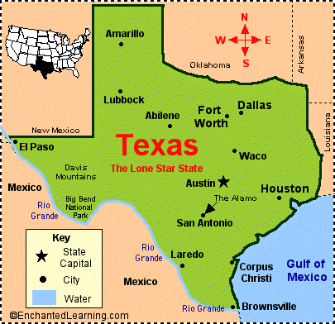**Remember, a velocity shows a speed and a direction. Use the map to help in directions. Again, show correct units.**

4. The workers placed 125 meters of asphalt in 2.5 hours from Austin to Dallas. What was their average **velocity**?

Answer:_______50 m/h_______NE______

**Formula: Equation:**

Velocity = speed + direction

S = D ÷ T

S = 125 ÷ 2.5 = 50

Direction = Northeast (NE)

j01394155. The Speed Racer is on his way to Houston from Austin. The speed racer drove for 24 minutes and found out that he traveled 144 kilometers. What was his average **velocity**?

Answer:_____6 km/ min_____SE________

**Formula: Equation:**

**V = S + direction S = D** ÷ T S = 144 ÷ 24 = 6

Direction =Southeast ( SE)