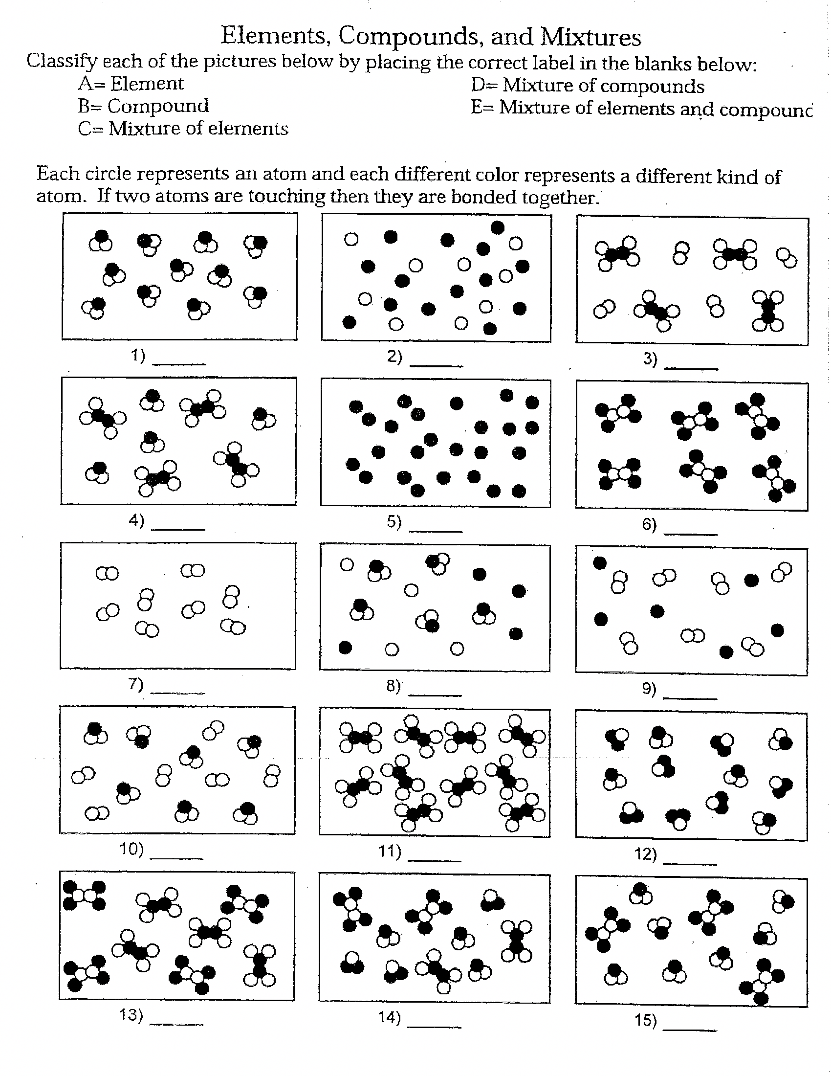

E = Mixture of Elements and Compounds

E = Mixture of Elements and Compounds

E = Mixture of Elements and Compounds

D =Mixture of Compounds

D =Mixture of Compounds

D =Mixture of Compounds

D =Mixture of Compounds

D =Mixture of Compounds

C = Mixture of Elements

C = Mixture of Elements

B = Compounds

B = Compounds

B = Compounds

1. Elements
2. Elements