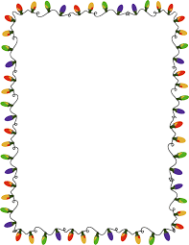
Hot Chocolate Semester Review

- Metric Unit
Hot chocolate is a liquid, circle the measurements below that are used for liquids. Also write what each abbreviation means next to the abbreviations.
L - Liters mm – Millimeters mL- Milliliters Km- Kilometers m- Meters cm- Centimeters

- Scientific Inquiry
If I were to do an experiment with Hot Chocolate, where I wanted to find out whether the increase or decrease in temperature would change the speed of chocolate powder dissolving in water, what would be my independent variable, dependent variable and controlled variables.
Independent:______ Temperature_______
Dependent: _______Time__________

Controlled Variables:_____ amount of water, amount of powder, same mug, etc._________

- Structure of Matter
When the coco powder is poured into the hot water it makes hot chocolate which is a ____Solution____ ( definition: a mixture in which a solute is dissolved in a solvent)

The chocolate chips are what state of matter? ____Solid______________
When they are added to the hot water they become what state of matter?_____liquid________

- Periodic Table
What elements can you think of that are used in hot chocolate? ____Hydrogen, Oxygen, (H2O = water)____

- Energy Transformations
When drinking hot chocolate you feel the heat when your hand touches the mug because of the thermal energy transfer of ____conduction_______ (conduction, convection, radiation)
Heat moves from ____warmer______ areas to ______cooler___ areas

- Force & Motion
If the force of gravity on the mug is 3N, and the force I put on the mug as I move it up to drink is 30N, what it the total net force? Is this balance or unbalance? ________27N_________ ____unbalanced____

