
Motion and Forces Learning Targets
Chapter 5, Sections 1 - 3

Target | Before we start | Still don’t know | Know some of it | Can Teach it
- I know the difference between a contact force and a noncontact force.
- I can give examples of contact forces and noncontact forces.
- I know the difference between a balanced force and an unbalanced force.
- I can identify examples of balanced forces and unbalanced forces.
- I can calculate Net Force when given a set of balanced or unbalanced forces.
- I know the type of units and the formula needed to calculate speed.
- I can calculate average speed.
- I know the type of units and the formula needed to calculate velocity.
- I can calculate average velocity.
- I can place distance and time on the correct axes on a line graph.
- I can calculate the intervals for a graph.
- I can plot distance and time on a graph correctly.
- I can interpret and analyze a graph to be able to calculate speed at any given point or average speed.
- I can identify what constant speed looks like on a graph.
- I can identify what stopping looks like on a graph.
- I can identify what speeding up or slowing down looks like on a graph
- I can demonstrate and explain how inclined planes can be used to change the amount of force to move an object.
- I can demonstrate and explain how pulleys can be used to change the amount of force to move an object.

Make and study flashcards for these vocabulary terms.

1. Reference point – the starting point you choose to describe the location, or position, of an object

2. Motion – the process of changing position

3. Speed – the distance an object moves in a unit of time

4. Constant Speed – when an object moves the same distance over a given unit of time

5. Average Speed – When the distance an object moves increases or decreases over a given unit of time
6. Velocity – the speed AND direction of a moving object

7. Distance/Time Graph – a graph that shows how distance and time are related

8. Force – a push or a pull on an object

9. Contact Force – a push or a pull one object applies to another object that is touching it

10. Noncontact Force – a force that one object applies to another object without touching it

11. Gravity – an attractive force that exists between all objects that have mass

12. Mass – the amount of matter in an object

13. Weight – the measure of the gravitational force acting on an object’s mass

14. Friction – a contact force that resists the sliding motion of two surfaces that are touching

15. Air Resistance – the frictional force between air and objects moving through it

16. Net Force – When more than one force acts on an object, the forces combine and act as one force. The sum of all the forces acting on an object is net force.

17. Balanced Force – If the net force on an object is 0 N

18. Unbalanced Force – if the net force on an object is not 0 N

19. Simple Machine – has only one or two parts and is the simplest form of a device that can make work easier

20. Inclined Plane (ramp) – a flat, sloped surface

21. Pulley – a simple machine that is a grooved wheel with a rope or a cable wrapped around it

22. Pulley System – a combination of fixed and movable pulleys that work together

Targets 1 and 2

Contact Force - _____________________________________________________________________________

Example: _________________________________________________________________________________

Noncontact Force - __________________________________________________________________________

Example: _________________________________________________________________________________

Targets 3, 4, and 5

Balanced Force - ___________________________________________________________________________

Unbalanced Force - _________________________________________________________________________
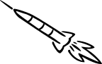
100N
200N

Is the picture to the left demonstrating a balanced force or an unbalanced force? _________________________________________

Calculate the net force:______________________________________

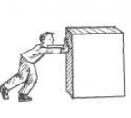
Is the picture to the left demonstrating a balanced force or an unbalanced force?__________________________________________
5N
5N
Calculate the net force:______________________________________

Target 6
What is the formula to calculate speed? ____________________________________________________

Target 7
A cheetah ran 100 m in 20 seconds. What was its average speed? _______________________________

Target 8
What is the formula to calculate velocity? __________________________________________________

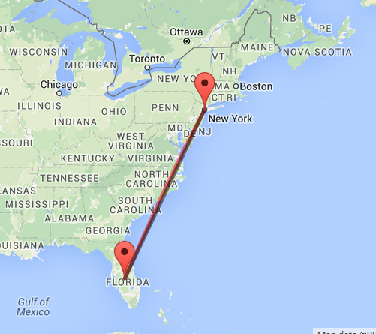
Target 9
The family took a vacation and traveled from Florida to New York. They traveled 1000 miles. It took them two days to make the trip. What was the average velocity on their trip?

Target 10
Place distance and time where they belong on the graph.

Target 11 - Explain
__________________________________________________________________________________________

__________________________________________________________________________________________
_______________If you have 10 horizontal lines above 0 and the highest number you have to graph is 975, what will the intervals be?

Target 12
Plot the turtle’s travel.

Time (sec) | Distance (cm)
0 | 0
3 | 30
6 | 60
9 | 90

Target 13
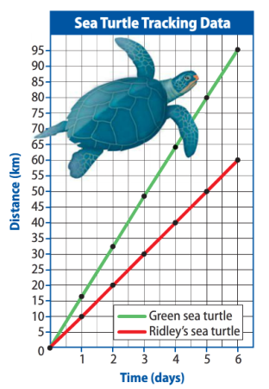
Which turtle traveled fastest? ______________________________

What is the speed of each turtle at 4 days?____________________

What is the average speed of each turtle?_____________________

Target 14, 15, and 16
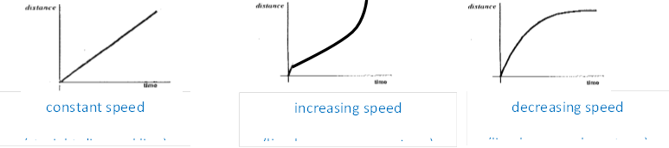
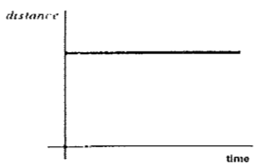
Under the graph, write if it is showing constant speed, stopping, increasing speed or decreasing speed.
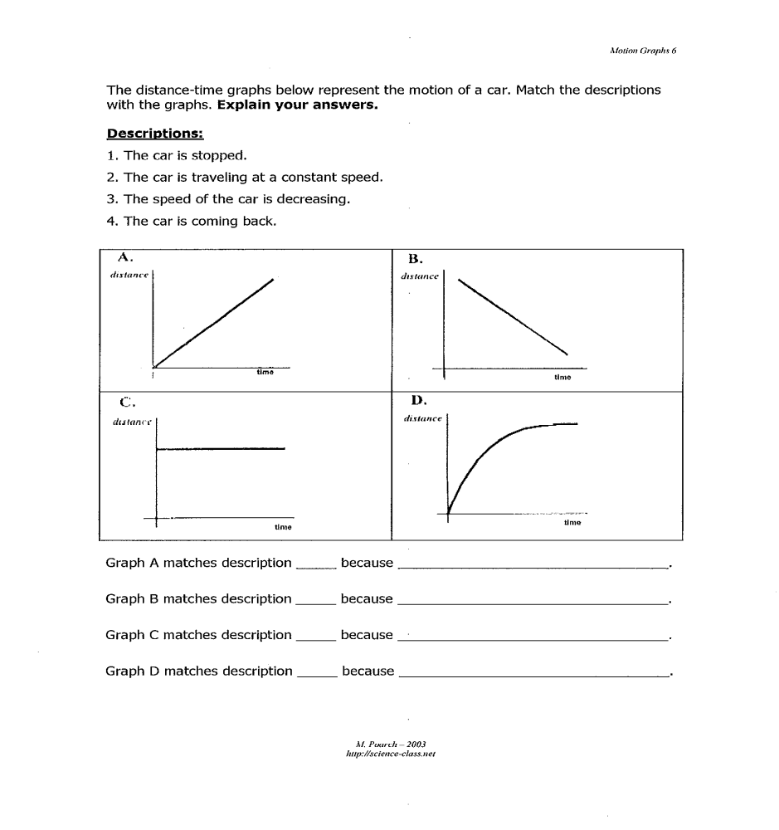
constant speed
(straight diaganol line)
decreasing speed
(line becomes less steep)
increasing speed
(line becomes more steep)
constant speed
(straight diaganol line)
decreasing speed
(line becomes less steep)
increasing speed
(line becomes more steep)
constant speed
(straight diaganol line)
decreasing speed
(line becomes less steep)
increasing speed
(line becomes more steep)
____________________ _____________________ ________________ __________________
constant speed
(straight diaganol line)
decreasing speed
(line becomes less steep)
increasing speed
(line becomes more steep)
constant speed
(straight diaganol line)
decreasing speed
(line becomes less steep)
increasing speed
(line becomes more steep)
Target 17
What are three ways a simple machine can make work easier?
___________________________________________________________________________________

___________________________________________________________________________________

___________________________________________________________________________________

How do you find mechanical advantage of an inclined plane?

___________________________________________________________________________________

Which of these inclined planes has the greatest mechanical advantage? Why?

12 m
18 m
4 m
3 m

Target 18
Label each type of pulley.
10N
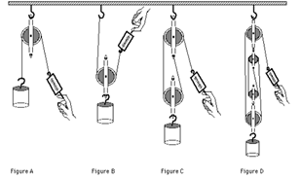
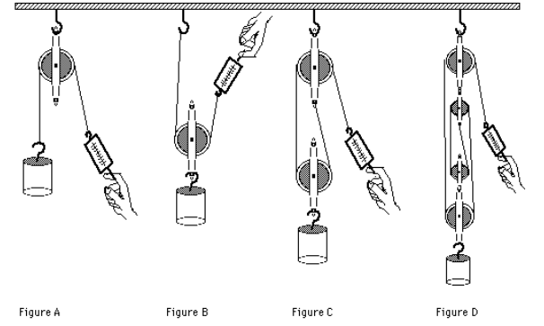
5N

15N
3N

15N
15N

15N
15N

How do you find mechanical advantage of a pulley?

What is the mechanical advantage of each pulley above?

Which pulley will make the work easiest?

