Purpose: To demonstrate the relationship between crustal plate motion and the occurrence of volcanoes, earthquakes, mountains, and ocean ridges or basins

Map Activity – Day 1
Part A: Crustal Plates
1. Highlight INSIDE the borders of each puzzle pieces (except the numbered edges) using a yellow highlighter.
2. Using ONLY colored pencils, color land areas light green (land areas do not have lines going through them)
3. Using ONLY colored pencils, color oceans light blue (Oceans do have lines going through them)
4. Cut the pieces out along the outer line and fit your puzzle pieces together, making sure the numbers and the lines are matching up as well as you can.
5. Line up the puzzle on a piece of construction paper so that the bottom right corner of the map is on the bottom right corner of the construction paper. GLUE (don’t tape) them on to the piece of construction paper.
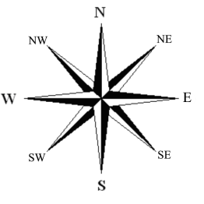
6. Make a compass rose in the lower left-hand corner.
7. At the top of the construction paper in the middle, title the paper “Plate Tectonics.”
8. Write your first and last names in the upper left-hand corner.
9. Read pages 284-285, and complete blue #1-2 before moving on.
Part B: Plate Motion
1. Using a black marker or pen, NEATLY label each plate listed in #2 with the name listed below.
2. Draw an arrow in black marker or pen showing the direction of the plate’s motion.
Write the names of the plates exactly as they are written below | Direction
North American Plate | West
South American Plate | West
African Plate | East
Eurasian Plate | South East
Indo-Australian Plate | North and North East
Pacific Plate | North West
Antarctic Plate | North West

Follow-up:
Finish reading 7.3, pages 286-292, (skipping page 291) and complete blue #3-4.
Purpose: To demonstrate the relationship between crustal plate motion and the occurrence of volcanoes, earthquakes, mountains, and ocean ridges or basins

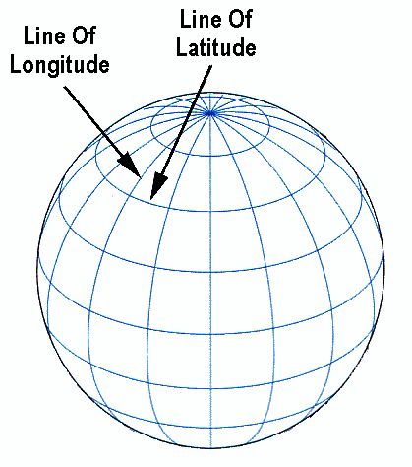
Map Activity – Day 2
Reminder about Plotting using Latitude and Longitude coordinates:
-Latitude lines go across the map. Any value followed by N is north of the equator (0˚);
S is south of the equator.
-Longitude lines go up and down the map. Any value followed by W is west of the prime meridian (0˚); E is east of the prime meridian.

Part C: Mountain Ranges
Using a purple pen or marker, locate and label the following mountain ranges using this symbol MMMM and the names of the ranges. The continents/country are there for your reference.
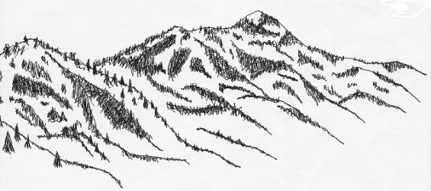

Mountain Ranges | Latitude | Longitude
a. Andes, South America | 32 S | 70W
b. Atlas, Africa | 31N | 8W
c. Himalayas, Nepal, India | 28N | 90E

Part D: Earthquake Watch
1. Use the data below to plot earthquakes.
2. Use a blue pen or marker to mark each earthquake’s location with a blue dot.
# | Latitude | Longitude |  | # | Latitude | Longitude
1 | 52 N | 173 W |  | 13 | 37 N | 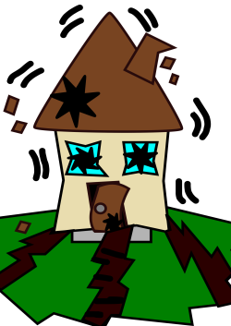  29 E
2 | 21 S | 70 W |  | 14 | 6 S | 104 E
3 | 15 N | 90 W |  | 15 | 11 S | 166 E
4 | 31 S | 66 W |  | 16 | 46 N | 158 W
5 | 10 N | 40 W |  | 17 | 22 S | 13 W
6 | 23 S | 173 W |  | 18 | 5 S | 77 W
7 | 15 S | 167 E |  | 19 | 42 N | 143 E
8 | 2 S | 62 E |  | 20 | 70 N | 6 E
9 | 50 N | 140 E |  | 21 | 3 S | 146 E
10 | 39 N | 46 E |  | 22 | 27 S | 50 E
11 | 55 S | 130 W |  | 23 | 53 N | 35 W
12 | 36 N | 31 W
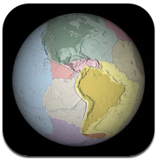
Follow-up:
When you are finished, go to self-service and download the Puzzling Plates app. Begin discovering and working in that app. You will eventually submit a screen shot of your best final score.

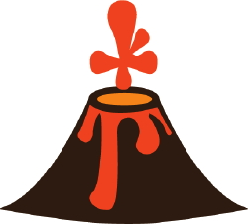
Plate Tectonic Map Activity – Day 3
Part E: Active and Dormant Volcanoes
1. Use the data below to plot volcanoes.
2. Use a red pen or marker to mark each volcano’s location with a red dot.
3. There is no need to write the name of the volcano. Those are listed just for your reference.
Volcano | Latitude | Longitude |  | Volcano | Latitude | Longitude
Sao Jorge Island | 39 N | 28 W |  | Pago | 6 N | 151 E
Tonga Island | 20 S | 175 E |  | Etna-just erupted! | 38 N | 15 E
Carlisle | 53 N | 170 W |  | Aconcagua | 33 S | 70 W
Beerenberg | 71 N | 8 W |  | Penatubo | 15 N | 120 E
Erebus | 77 S | 167 E |  | Kilauea | 19 N | 155 W
Tinakula | 10 S | 166 E |  | Pagan Island | 18 N | 146 E
Fuji | 35 N | 139 E |  | Ranier | 47 N | 122 W
Merapi | 7 S | 110 E |  | Sandwich Island | 54 S | 37 W
Lassen | 40 N | 122 W |  | San Miguel | 13 N | 88 W
Pelee | 15 N | 61 W |  | Hekla | 64 N | 20 W
Mauna Loa | 19 N | 156 W |  | Huascaran | 9 S | 78 W
Fiji | 18 S | 179 E |  | Bonin | 27 N | 142 E
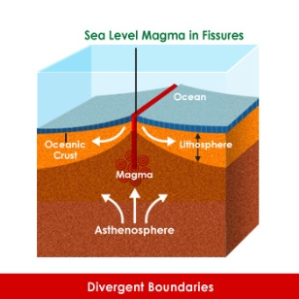
Part F: Basins/Ridges
On Safari, search to find where the Mid-Atlantic Ridge and the Central-Indian Ridge are on the map. Draw and LABEL them in black pen or marker.

Part G: Summary
1. Pick up the hard-copy portion of the information below from your teacher.
2. Glue/Tape it to the back of your map. Answer the questions. Refer to pages 284-293 if needed.
1. Where do most earthquakes and volcanoes occur, in the middle of crustal plates or near the plate edges/boundaries?___________________________________________________
2. Describe what happens when the plates move at each of the following plate boundaries, and give examples of landforms/events that result from each plate boundary.
Type of Boundary | How plates move | Events/Landforms
Divergent
Convergent
Transform

Follow-up:
1. Make sure your map is complete. You will use it tomorrow for a learning check.
2. Once you have ensured completion, continue working on the Puzzling Plates app, trying to improve your over-all score.

