MC900391186[1]MC900361712[1]Name ____Answer Key__________________ Class # _____ Date ____________________

**The Nuts and Bolts of Elements, Compounds and Mixtures**

Elements and compounds can be combined in many different ways. There may just be one kind of element or there may be a mixture of elements. There may be only one kind of compound or there may be a mixture of compounds. You may also find mixtures of elements and compounds together or mixtures of different compounds together or mixtures of different elements together.

Look at the following boxes and analyze what is inside box. Use the terms:

**Elements** (same) **Compounds** (same) **Mixture of Elements** (different) **Mixture of Compounds** (different) **Mixture of Elements and Compounds**

O2 O2 O2

O2  O2  O2

NaCl NaCl

NaCl NaCl

O2  H2 O2

H2  O2  H2

A._______Elements_______ B. ________Compounds_______ C _____Mixture of Elements___

H2O H2O2

H2O2 H2O

O2 NaCl H2

H2O O2 H2O

D.___Mixture of Compounds_________ E. __Mixture of Elements and Compounds__

Sometimes representations are used in place of actual element symbols or compounds.

Using the same thought processes as above, identify these substances.

F___Mixture of Elements_______ G_____Elements___________ H____Compounds_______

I____Elements_______ J_____Mixture of Elements______ K_Mixture of Elements/Compounds

L. _Mixture of Compounds______

Now you are going to look at a variety of substances that have been represented by nuts, bolts, washers, and other items. Identify each as…

Write an “E” in front of an element. Write a “C” in front of a compound.

**-Element  
-Compound  
-Mixture of elements  
-Mixture of compounds  
-Mixture of compounds and elements**

|  |  |
| --- | --- |
| **Station** | **Classification** |
| **1** |  |
| **2** |  |
| **3** |  |
| **4** |  |
| **5** |  |
| **6** |  |
| **7** |  |
| **8** |  |
| **9** |  |
| **10** |  |
| **11** |  |
| **12** |  |
| **13** |  |
| **14** |  |

**__E___ H**

**__C___CaCO3**

**___C__ CO2**

**___E__O**

**___E__ Co**

**__C___ CO**

**__E___ Ca**

**__C__ SiO2**

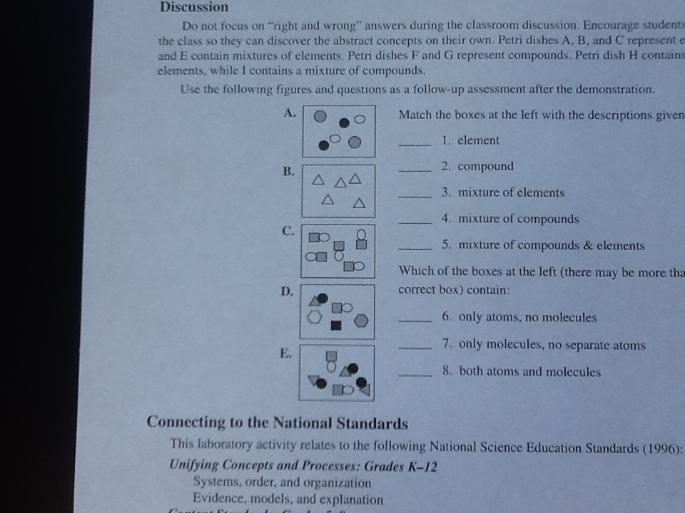**By yourself** – Identify the following diagrams with the same terms as above.

Elements



Compounds

_Mixture of Compounds

Mixture of Elements

Elements

Mixture of Elements and Compounds

F.

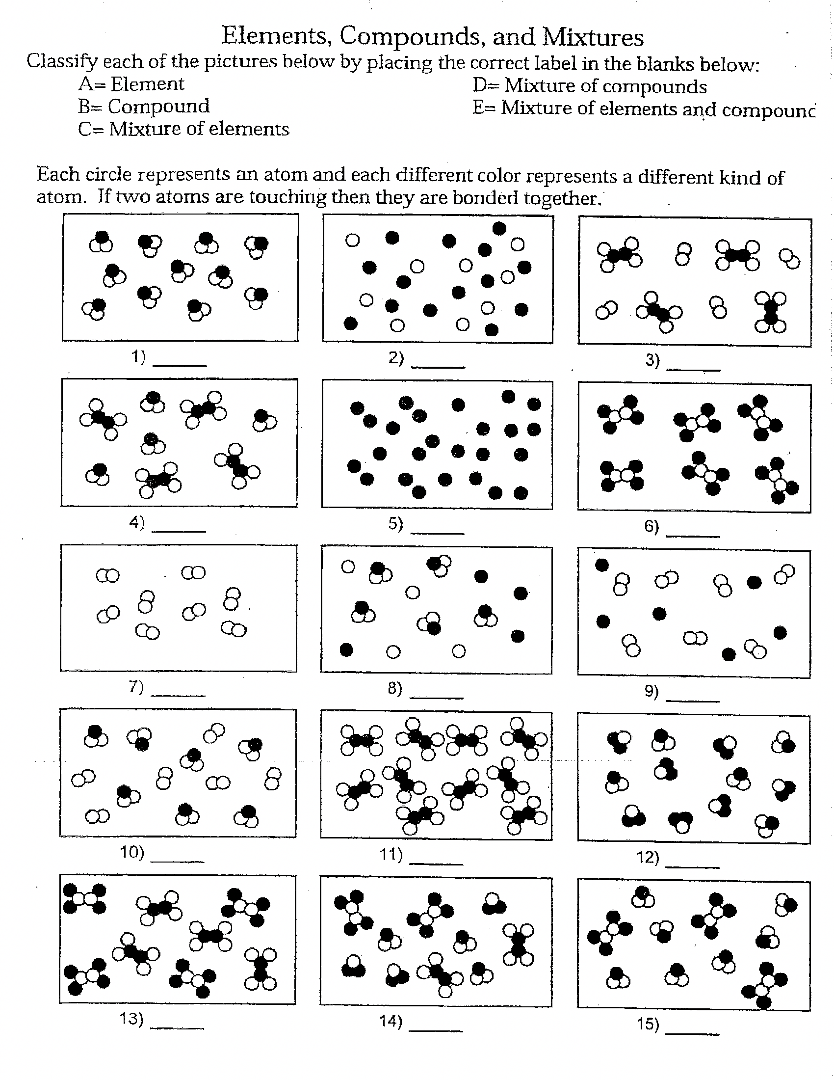

E = Mixture of Elements and Compounds

E = Mixture of Elements and Compounds

E = Mixture of Elements and Compounds

D =Mixture of Compounds

D =Mixture of Compounds

D =Mixture of Compounds

D =Mixture of Compounds

D =Mixture of Compounds

C = Mixture of Elements

C = Mixture of Elements

B = Compounds

B = Compounds

B = Compounds

1. Elements
2. Elements